COVID-19 lockdown impact: Percentage of consumers able to find essential goods at retail stores & ecommerce apps shows marginal improvement but situation remains worrisome
- Percentage of consumers able to find essentials via ‘ecommerce apps’ rises from 39% to 41%
- Percentage of consumers able to find essentials at ‘local retail stores’ rises from 57% to 60%

30th March 2020, New Delhi: The Availability of essential goods has been a major concern raised on LocalCircles by consumers across the nation over the past 9 days. In this time of COVID-19 outbreak, LocalCircles has been continuously tracking the on-ground change that has been taking place in the availability of essential goods in retail store, as well as on ecommerce platforms. The same is regularly being escalated to Central Government and State Governments. The root cause was identified as lack of clear instructions to police and local officials on the ground which has been leading to restrictions on movement of vehicles carrying essential goods and people who are engaged in warehousing, wholesale, retail and home delivery of essential goods.
Post the escalations by LocalCircles, industry and Government stakeholders, the Home Ministry last week laid down ‘Standard Operating Procedures’ for maintaining the supply of essential commodities in local retail stores, organised retail stores, as well as on ecommerce apps, and ensure that entire supply chain is allowed to operate uninterrupted.
The essential goods survey for March 25-26 indicated that 61% of those who ordered essential goods via an ecommerce app could not get them and 43% of those who went to local retail stores could not get most of the essential goods they wanted. To continue tracking these metrics, LocalCircles conducted the 4th consumer survey on March 27-28. The survey received 17,000+ responses from consumers located in 181 districts of India.
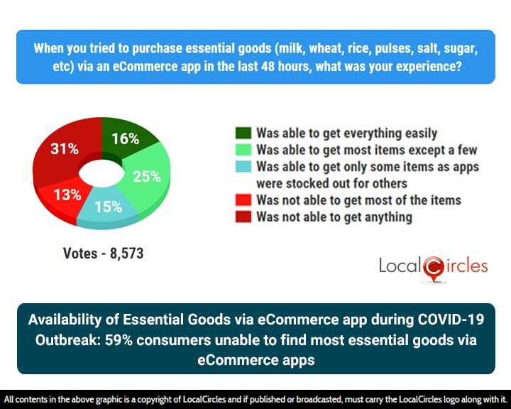

The first question asked consumers when they placed an order for essential goods (wheat, rice, pulses, salt, sugar, etc) from an eCommerce app during the last 48 hours, how was their experience. 25% said they were able to get most items while 15% said they were able to get only some items as online stores were stocked out for others. 13% said they were not able to get most items while 31% said they were not able to get anything. Only 16% said they were able to get everything easily.
The Government has been working to remove the hurdles in the way of essential supplies reaching consumers. When compared with the data from March 25-26, the percentage of consumers who were able to find essential goods via an eCommerce app, has increased from 39% to 41% in the last 2 days. This indicates that it has become a little easier for the ecommerce companies to operate during the lockdown. Based on feedback from Government and industry players, many local district administrations or local police officials have now issued notifications supporting unrestricted movement of essentials and delivery personnel carrying these essentials. This has led to atleast some of the ecommerce platforms opening order acceptance, however most are still promising long order fulfilment times, as much as one week in many cases given the backlog they have.
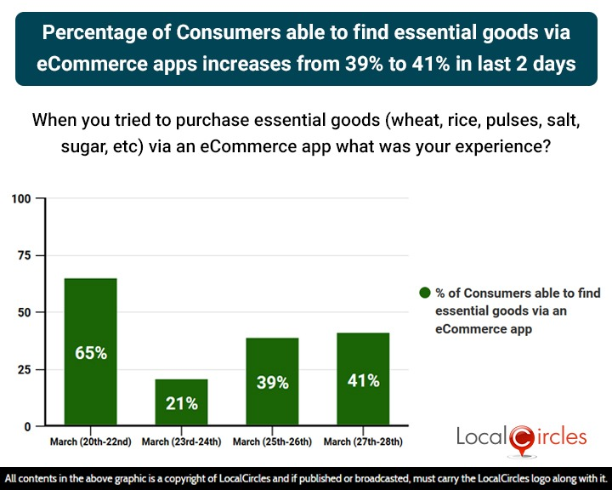
Based on feedback from Government and industry players, the Ministry of Home Affairs directive and some state/local authorities issuing notification has helped in supporting movement of essentials and delivery personnel carrying these essentials. Obtaining curfew passes for personnel is still a challenge in many parts of the country. In addition, availability of workforce is also a challenge now for warehousing and delivery via ecommerce apps now. As a result, most ecommerce platforms are still not accepting orders for essential goods in most cities and if an order is accepted, long fulfilment times of 5-6 days (versus 1-2 in normal circumstances) is being promised to consumers.
Consumers were also asked when they tried to purchase essential goods (wheat, rice, pulses, salt, sugar, etc) from a retail store during the last 48 hours, what was their experience like. 25% said they were able to get everything easily while 35% said they were able to get most items except a few. 18% said they were able to get only some items as stores were stocked out for others and 17% said they were not able to get most of the items. 5% said they were not able to get anything.
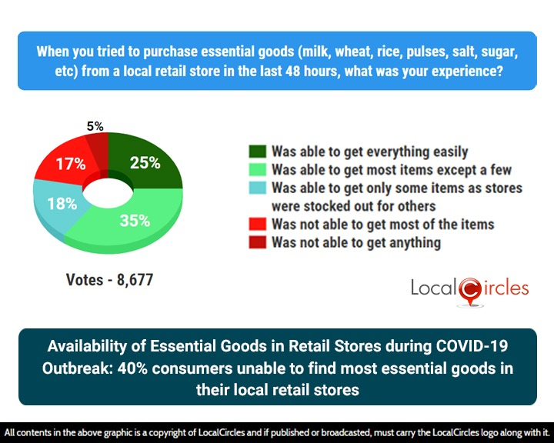
When this is compared to the findings of the survey conducted for March 25-26, the percentage of consumers who were able to find essential goods at their local retail stores has shown a little improvement, and now stands at 60% from the earlier 57%.
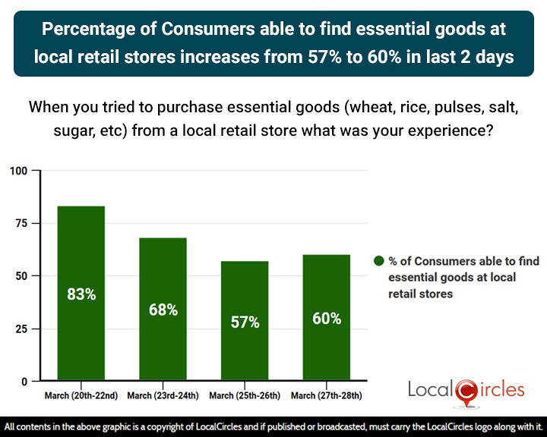
The key challenge reported by consumers is that many local retail stores are still closed and not delivering because their owners and managers have still not received the curfew passes in many parts of the country. While the process has been laid out by the authorities, the logistics have still not been completed for many of them to open their stores, receive goods, sell and deliver to consumers. In addition, it has been reported that the stores are missing a good percentage of their workforce as many have gone back to their hometowns/villages.
The collective view and that of LocalCircles is that trucks carrying essential goods and personnel engaged in warehousing, retail and delivery of the same must not be subjected to the requirement of curfew passes by local authorities. Instead, they should be permitted to operate on the basis of a signed letter from the ecommerce platform or the retail company authorising the individual and corroborated by identifying them with a valid Government identity. The curfew pass requirement should only apply to personnel operating from unorganised retail sector. This will ease the workload at offices granting curfew passes while ensuring there are checks and balances and overall help in improving availability of essential goods for consumers.
LocalCircles will be submitting the findings of this report to various stakeholders in the Central Government and State Governments requesting them to take actions highlighted in this report and drive further improvement in availability of essential goods via retail stores and ecommerce platforms.

About LocalCircles
LocalCircles takes Social Media to the next level and makes it about Communities, Governance and Utility. It enables citizens to connect with communities for most aspects of urban daily life like Neighborhood, Constituency, City, Government, Causes, Interests and Needs, seek information/assistance when needed, come together for various initiatives and improve their urban daily life. LocalCircles is free for citizens and always will be!
Akshay Gupta- media@localcircles.com, +91-8585909866

